1.67: a)
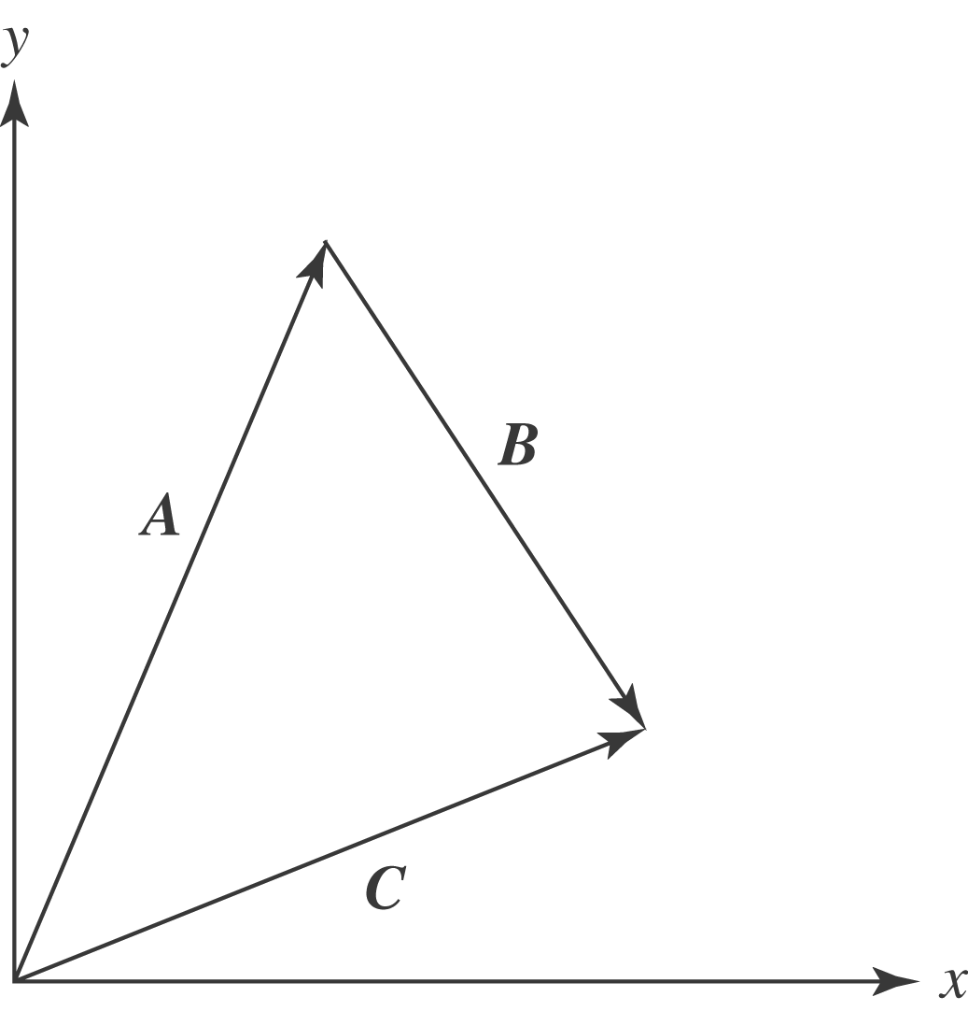

b) Algebraically,
